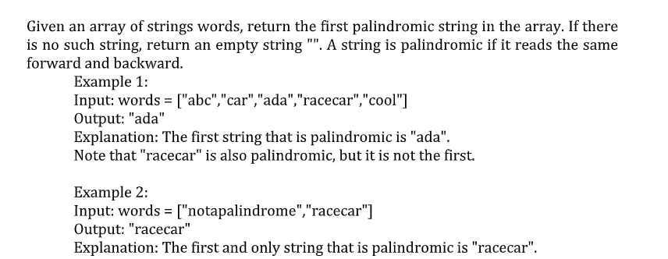

Program :
#include <stdio.h>
#include <string.h>
int isPalindrome(char word[]){
int i, len;
len = strlen(word);
for (i = 0; i < len / 2; i++){
if (word[i] != word[len - i - 1]){
return 0;
}
}
return 1;
}
int main(){
int n, i;
char words[100][100];
printf("Enter number of strings: ");
scanf("%d", &n);
printf("Enter the strings:\n");
for (i = 0; i < n; i++){
scanf("%s", words[i]);
}
for (i = 0; i < n; i++){
if (isPalindrome(words[i])){
printf("First palindrome: %s", words[i]);
return 0;
}
}
printf("No palindrome found");
return 0;
}
Input:
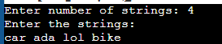
Output:
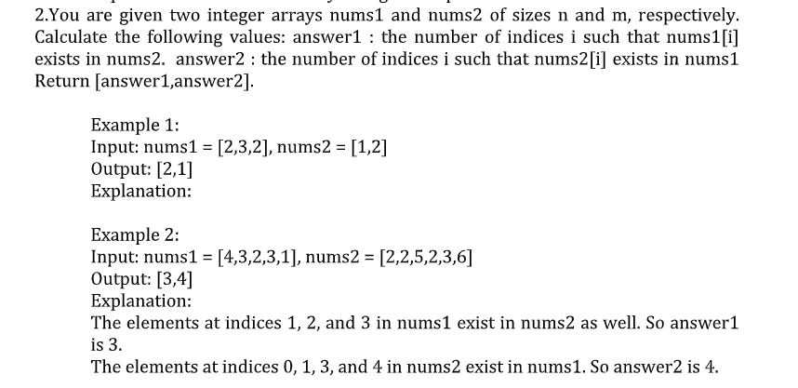
#include <stdio.h>
int exists(int arr[], int size, int value) {
for (int i = 0; i < size; i++)
if (arr[i] == value)
return 1;
return 0;
}
int main() {
int nums1[100], nums2[100];
int n, m;
int answer1 = 0, answer2 = 0;
printf("Enter size of nums1: ");
scanf("%d", &n);
printf("Enter %d elements of nums1: ", n);
for (int i = 0; i < n; i++)
scanf("%d", &nums1[i]);
printf("Enter size of nums2: ");
scanf("%d", &m);
printf("Enter %d elements of nums2: ", m);
for (int i = 0; i < m; i++)
scanf("%d", &nums2[i]);
for (int i = 0; i < n; i++)
if (exists(nums2, m, nums1[i]))
answer1++;
for (int i = 0; i < m; i++)
if (exists(nums1, n, nums2[i]))
answer2++;
printf("Output: [%d,%d]\n", answer1, answer2);
return 0;
}
Input :
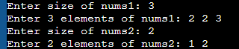
Output :
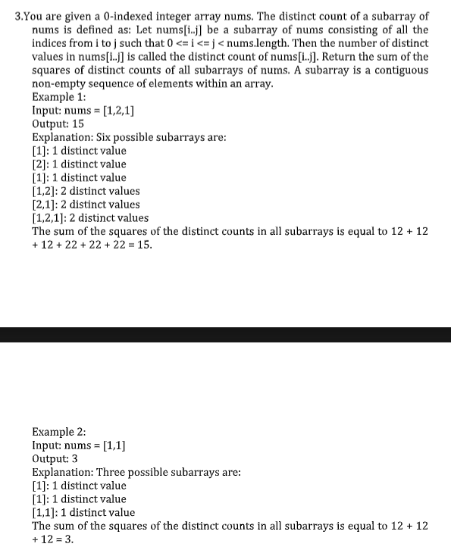
#include <stdio.h>
int main() {
int nums[100];
int n, total = 0;
printf("Enter size of array: ");
scanf("%d", &n);
printf("Enter %d elements: ", n);
for (int i = 0; i < n; i++)
scanf("%d", &nums[i]);
for (int i = 0; i < n; i++) {
for (int j = i; j < n; j++) {
// count distinct values in nums[i..j]
int distinct = 0;
for (int k = i; k <= j; k++) {
int seen = 0;
for (int p = i; p < k; p++) {
if (nums[p] == nums[k]) {
seen = 1;
break;
}
}
if (!seen)
distinct++;
}
total += distinct * distinct;
}
}
printf("Output: %d\n", total);
return 0;
}
Input :
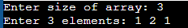
Output :
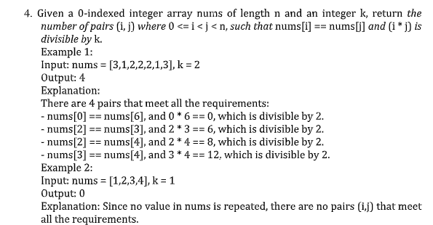
#include <stdio.h>
int main() {
int nums[100];
int n, k, count = 0;
printf("Enter size of array: ");
scanf("%d", &n);
printf("Enter %d elements: ", n);
for (int i = 0; i < n; i++)
scanf("%d", &nums[i]);
printf("Enter k: ");
scanf("%d", &k);
for (int i = 0; i < n; i++) {
for (int j = i + 1; j < n; j++) {
if (nums[i] == nums[j] && (i * j) % k == 0)
count++;
}
}
printf("Output: %d\n", count);
return 0;
}
Input :
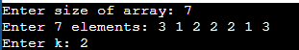
Output :
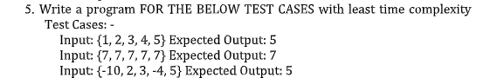

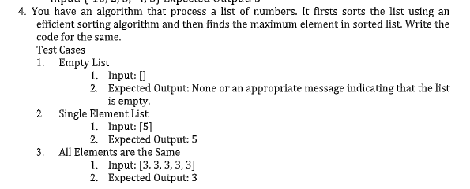
#include <stdio.h>
void merge(int arr[], int left, int mid, int right) {
int temp[100];
int i = left, j = mid + 1, k = 0;
while (i <= mid && j <= right) {
if (arr[i] <= arr[j]) temp[k++] = arr[i++];
else temp[k++] = arr[j++];
}
while (i <= mid) temp[k++] = arr[i++];
while (j <= right) temp[k++] = arr[j++];

for (i = 0; i < k; i++)
arr[left + i] = temp[i];
}
void mergeSort(int arr[], int left, int right) {
if (left < right) {
int mid = (left + right) / 2;
mergeSort(arr, left, mid);
mergeSort(arr, mid + 1, right);
merge(arr, left, mid, right);
}
}
int main() {
int arr[100];
int n;
printf("Enter size of list: ");
scanf("%d", &n);
if (n <= 0) {
printf("List is empty\n");
return 0;
}
printf("Enter %d elements: ", n);
for (int i = 0; i < n; i++)
scanf("%d", &arr[i]);
mergeSort(arr, 0, n - 1);
printf("Maximum = %d\n", arr[n - 1]);
return 0;
}
Input & Output :
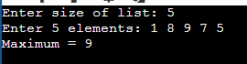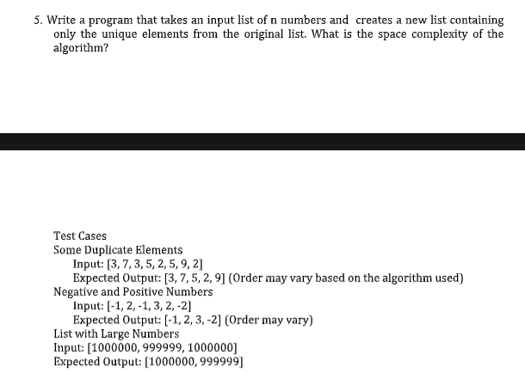
#include <stdio.h>
int main() {
int arr[100], unique[100];
int n, count = 0;
printf("Enter size of list: ");
scanf("%d", &n);
printf("Enter %d elements: ", n);
for (int i = 0; i < n; i++)
scanf("%d", &arr[i]);
for (int i = 0; i < n; i++) {
int duplicate = 0;
for (int j = 0; j < count; j++) {
if (unique[j] == arr[i]) {
duplicate = 1;
break;
}
}
if (!duplicate)
unique[count++] = arr[i];
}
printf("Unique list: [");
for (int i = 0; i < count; i++) {
printf("%d", unique[i]);
if (i < count - 1) printf(", ");
}
printf("]\n");
return 0;
}
Input & Output :
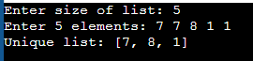
#include <stdio.h>
int main() {
int arr[100];
int n;
printf("Enter size of array: ");
scanf("%d", &n);
printf("Enter %d elements: ", n);
for (int i = 0; i < n; i++)
scanf("%d", &arr[i]);
for (int i = 0; i < n - 1; i++) {
int swapped = 0;
for (int j = 0; j < n - 1 - i; j++) {
if (arr[j] > arr[j + 1]) {
int temp = arr[j];
arr[j] = arr[j + 1];
arr[j + 1] = temp;
swapped = 1;
}
}
if (!swapped)
break;
}
printf("Sorted array: ");
for (int i = 0; i < n; i++)
printf("%d ", arr[i]);
printf("\n");
return 0;
}
Input & Output :
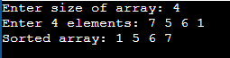
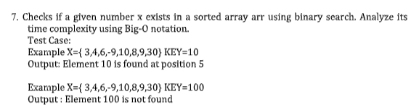
#include <stdio.h>
int binarySearch(int arr[], int n, int key) {
int low = 0, high = n - 1;
while (low <= high) {
int mid = (low + high) / 2;
if (arr[mid] == key)
return mid;
else if (arr[mid] < key)
low = mid + 1;
else
high = mid - 1;
}
return -1;
}
int main() {
int original[100], sorted[100];
int n, key;
printf("Enter size of array: ");
scanf("%d", &n);
printf("Enter %d elements: ", n);
for (int i = 0; i < n; i++) {
scanf("%d", &original[i]);
sorted[i] = original[i];
}
printf("Enter key to search: ");
scanf("%d", &key);
for (int i = 0; i < n - 1; i++)
for (int j = 0; j < n - 1 - i; j++)
if (sorted[j] > sorted[j + 1]) {
int t = sorted[j];
sorted[j] = sorted[j + 1];
sorted[j + 1] = t;
}
if (binarySearch(sorted, n, key) == -1) {
printf("Element %d is not found\n", key);
} else {
for (int i = 0; i < n; i++)
if (original[i] == key) {
printf("Element %d is found at position %d\n", key, i + 1);
break;
}
}
return 0;
}
Input & Output :
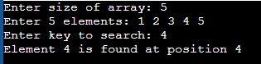
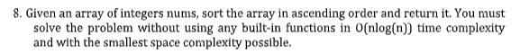
#include <stdio.h>
void merge(int arr[], int left, int mid, int right) {
int temp[100];
int i = left, j = mid + 1, k = 0;
while (i <= mid && j <= right) {
if (arr[i] <= arr[j]) temp[k++] = arr[i++];
else temp[k++] = arr[j++];
}
while (i <= mid) temp[k++] = arr[i++];
while (j <= right) temp[k++] = arr[j++];

for (i = 0; i < k; i++)
arr[left + i] = temp[i];
}
void mergeSort(int arr[], int left, int right) {
if (left < right) {
int mid = (left + right) / 2;
mergeSort(arr, left, mid);
mergeSort(arr, mid + 1, right);
merge(arr, left, mid, right);
}
}
int main() {
int arr[100];
int n;
printf("Enter size of list: ");
scanf("%d", &n);
if (n <= 0) {
printf("List is empty\n");
return 0;
}
printf("Enter %d elements: ", n);
for (int i = 0; i < n; i++)
scanf("%d", &arr[i]);
mergeSort(arr, 0, n - 1);
printf("Maximum = %d\n", arr[n - 1]); // last element after sorting
return 0;
}
Input & Output:
